**Digital twin for buildings (Twin4build)**

**What is a Digital Twin?**

A digital twin is like a virtual copy of a real object or system, like a car or a factory. It helps us understand and predict how the real thing behaves, so we can make improvements or solve problems without having to experiment directly on the real object.

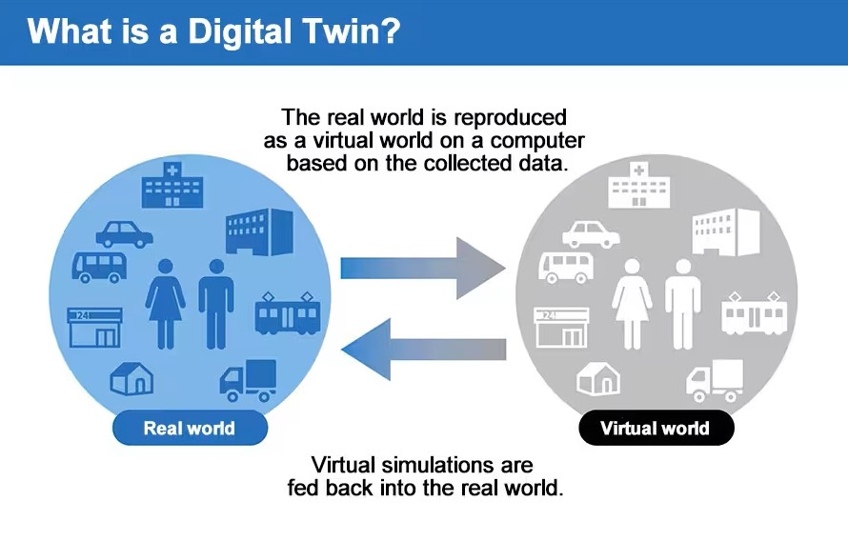

**What is a Digital Twin for smart buildings?**

A digital twin for buildings is a virtual replica of a physical building, containing detailed information about its structure, systems, and operations. It helps building owners and managers monitor performance, optimize energy usage, and identify potential issues to improve efficiency and maintenance. 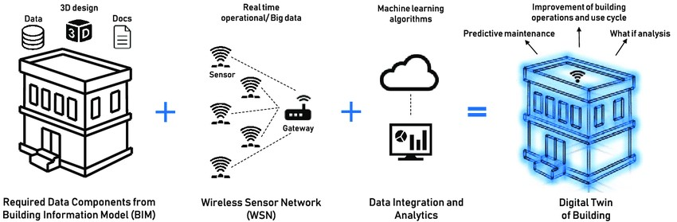

**How do Smart Building Digital Twins Work?**

A smart building digital twin essentially acts as a bridge between the digital and physical worlds. It does so by using connected sensors and IoT devices to collect real-time data about physical items. This data is then combined with context and processed and is used to understand, analyse, manipulate, and optimize processes within a smart building.

To implement a smart building digital twin, four key enabling factors are needed:

1. **Data.** Data from across the entire smart building is needed, such as data about people, processes, connected devices, operational building systems, IT and external information like weather or transit feeds.
2. **Context.**Context includes real-time information about the actual state of the building, what actions occupants are taking, the behaviour of the devices and the state of the workflows.
3. **Reasoning.**A method for applying reasoning to data is needed to drive action. Most commonly, reasoning is based on asynchronously processed rules, artificial intelligence (AI) or machine learning (ML) models, or temporal reasoning for varied frequency of events.
4. **Key Performance Indicators (KPIs).**KPIs are required to provide meaningful business context and to ensure alignment between objectives and performance measurement.

**What are the Benefits of a Smart Building Digital Twin?**

By providing a contextual model of your building and operations, smart building digital twins offer:

* Transformative spatial awareness
* Analyses of root causes
* Intelligent recommendations
* Ability to self-tune
* Insight needed for predictive maintenance.

This means smart building digital twins benefit everyone in the building from the owner and operator to the building manager, to the tenants and their employees. They do so by allowing data, workflows, and human behaviours in the portfolio to be analysed in real-time and by enabling immediate action to be taken to optimize performance/conditions.

**Twin4Build**

Goal of the project is to assist building owners and managers to greatly improve building performance and save cost via coordinated decision support over the whole building life cycle with

15% reduction in building energy demand

Up to 25% reduction in CO2 and greenhouse gas emission

High level diagram:

ss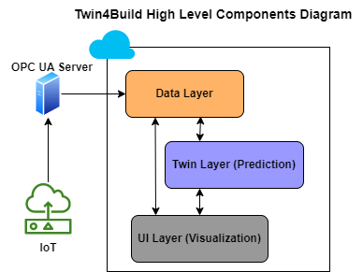

High level diagram explained:

* IoT (Internet of Things): This symbolizes the network of physical devices, such as sensors and actuators, embedded with software and connectivity which enables them to connect and exchange data with the OPC UA server and, in turn, with the digital twin system. These IoT devices could be monitoring various aspects of a building, like temperature, energy usage, structural integrity, etc.
* OPC UA Server: OPC UA (Open Platform Communications Unified Architecture) is a machine-to-machine communication protocol for industrial automation. An OPC UA server would collect data from physical devices (IoT devices) and send it to the digital twin system. It may also receive commands from the digital twin system to control the physical devices.
* Data Layer: This component refers to the storage, management, and processing of data collected from the IoT devices. It's where data is analysed and transformed into information that the digital twin can use to do simulation, analysis, and visualization.
* Twin Layer (Prediction): This layer of the digital twin uses the information from the data layer to create predictive models. These models help to forecast future states of the building based on current and historical data. It can predict things like equipment failure, energy usage trends, or the need for maintenance.
* UI Layer (Visualization): This is the user interface layer where the data and predictions from the twin layer are presented in a visual format that can be easily understood and interacted with by humans. It would include dashboards, alerts and other visualization tools that help users make decisions about the management of the building.

Twin layer Data flow diagram:

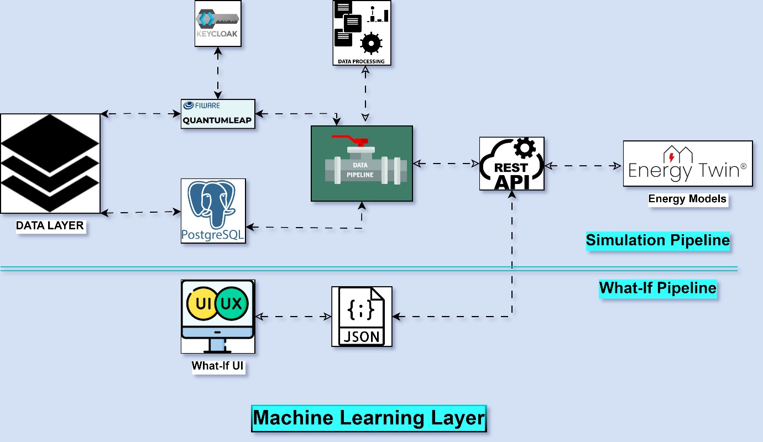

**Why we need simulations?**

Simulations play a crucial role in providing insights into various aspects of the building's performance, behaviour, and interactions with its environment. Simulations help to create a virtual representation of the physical building and its systems, allowing for predictive analysis, optimization, and decision-making. Here's how simulations are typically utilized within the framework of a digital twin for buildings:

1. **Energy Simulation:** Energy simulation tools are used to model the energy consumption of the building based on its design, construction materials, HVAC systems, occupancy patterns, and external environmental factors such as weather conditions. By simulating energy usage, building owners and operators can identify opportunities for energy efficiency improvements, optimize HVAC settings, and evaluate the impact of different energy-saving measures.
2. **Thermal Comfort Simulation:** Simulations are employed to assess thermal comfort levels within the building spaces. By considering factors such as air temperature, humidity, air velocity, and occupant activities, these simulations help to optimize HVAC system settings and building design to ensure occupants' comfort and well-being.
3. **Daylighting Simulation:** Daylighting simulations evaluate the distribution of natural light within the building throughout the day and across different seasons. These simulations help architects and designers to optimize building layouts, window placements, and shading devices to maximize natural lighting while minimizing glare and excessive heat gain.
4. **Occupant Behaviour Simulation:** Simulating occupant behaviour allows building operators to understand how occupants interact with the building environment, such as their usage patterns of lighting, HVAC systems, and other amenities. This insight can inform building design and operation strategies to enhance occupant satisfaction, productivity, and well-being.
5. **Fire and Smoke Simulation:** Fire and smoke simulations predict the behaviour of fire and smoke within the building in the event of a fire outbreak. These simulations help to optimize fire safety measures, such as the placement of fire alarms, sprinkler systems, evacuation routes, and smoke control systems, to minimize the risk to occupants and property.
6. **Operational Simulation:** Operational simulations model the day-to-day operation of building systems, including HVAC, lighting, security, and maintenance activities. By simulating different scenarios and operational strategies, building operators can optimize resource utilization, reduce operational costs, and improve overall building performance.

Type of simulation based on time:

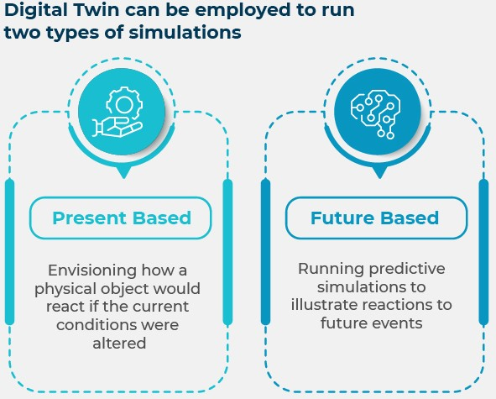

**What is HVAC System?**

HVAC systems are indispensable components of modern buildings, providing essential heating, ventilation, and air conditioning services.

1. **Heating:** Heating systems provide warmth during cold weather by generating and distributing heat throughout a building. Examples include furnaces, boilers, heat pumps, and electric heaters.
2. **Ventilation:** Ventilation systems ensure the circulation of fresh air throughout the building while removing stale air, odours, and contaminants. They typically involve fans, ductwork, and air vents to facilitate airflow.
3. **Air Conditioning**: Air conditioning systems regulate indoor temperature and humidity levels, keeping occupants cool and comfortable during hot weather. Examples include central air conditioning units, split-system air conditioners, and ductless mini-split systems.

**Benefits of HVAC based implementation.**

The integration of HVAC (Heating, Ventilation, and Air Conditioning) systems within this framework holds immense promise in meeting ambitious energy reduction and emissions targets. Here’s a breakdown of their importance:

1. **Energy Efficiency**: Heating and ventilation are significant contributors to a building's energy consumption. By deploying digital twins, we can precisely simulate and optimize these systems' operations to minimize energy usage without compromising comfort. Real-time data monitoring, coupled with predictive analytics, enables proactive adjustments to achieve optimal energy efficiency.
2. **Emissions Reduction**: HVAC systems, especially those reliant on fossil fuels, contribute substantially to CO2 and greenhouse gas emissions. Through digital twins, we can model various scenarios and assess the environmental impact of different operational strategies. By fine-tuning system parameters and integrating renewable energy sources, we can significantly mitigate emissions, aligning with sustainability goals.
3. **Occupant Comfort and Health**: Proper ventilation is crucial for maintaining indoor air quality and promoting occupant well-being. Digital twins allow for the optimization of ventilation rates, air distribution, and filtration systems, ensuring a healthy indoor environment. By dynamically adjusting ventilation parameters based on occupancy patterns and external conditions, we can enhance comfort while minimizing energy waste.
4. **Predictive Maintenance**: HVAC systems require regular maintenance to operate efficiently. Digital twins facilitate predictive maintenance by continuously monitoring system performance and identifying potential issues before they escalate. Proactive maintenance not only extends equipment lifespan but also minimizes downtime and reduces operational costs.
5. **Resilience and Adaptability**: Climate change poses evolving challenges to building operations. Digital twins provide a platform for scenario modelling and resilience planning. By simulating extreme weather events and assessing their impact on heating and ventilation systems, building managers can implement adaptive strategies to ensure continuity of operations and occupant safety.

In essence, the implementation of heating and ventilation system twins within the digital twin framework empowers building owners and operators to achieve significant advancements in energy efficiency, emissions reduction, occupant comfort, and operational resilience. By leveraging data-driven insights and advanced simulation capabilities, we can pave the way towards sustainable and resilient built environments, contributing to a greener and healthier future.

**What-if scenario**

A "what-if scenario" is like a virtual experiment where we explore different possibilities or situations to see what could happen. It's a way of testing various options without having to do them in real life.

By using the "what-if scenario" feature, we can identify opportunities to optimize the building's performance and reduce energy consumption. For instance, we can test if adjusting the HVAC system or implementing energy-efficient lighting would lead to cost savings or leads to comforts for persons in building by making these adjustments virtually first, we can avoid unnecessary expenses on changes that may not have the desired outcome.

What if Scenarios for Twin4build:

1. Temperature Scenario: This scenario lets you adjust the temperature of a specific room and see how the room responds. You can find out how much energy is used for heating, how much CO2 is produced, and assess the comfort level in the room.
2. Occupancy Scenario: With this scenario, you can change the number of people in a room and observe its effects. You'll see how occupancy affects room comfort, CO2 levels, and temperature.
3. Shade Schedule Scenario: Here, you can modify the schedule for window shades in a room. This helps you understand how adjusting shades impacts room temperature, heating energy usage, and identifies the best schedule to enhance room comfort.
4. Supply Water Temperature Schedule: By altering the supply water temperature used for heating the room, this scenario helps us predict the room's behaviour under different heating conditions.
5. Supply Air Temperature Schedule: Like the supply water temperature scenario, this one focuses on adjusting the supply air temperature for heating purposes.

By combining these scenarios, we can determine the most effective solutions for each room. Implementing these findings can lead to improved room comfort, reduced energy consumption, and lower CO2 emissions.